Template
Stakeholder Survey
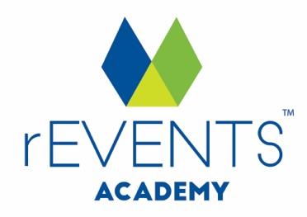
IMPORTANT: Copyright Notice
Except as permitted under the Copyright Act 1968 (Cth), you are not permitted to copy, reproduce, republish, distribute or display any of the information on our website or in our toolkits and resources without our prior written permission.
rEVENTS Academy maintains the copyright on all graphics, images, layouts, text, logos and trademarks contained within our website and toolkits. This includes following any removal of rEVENTS Academy branding and copyright notices for customisation of this document.
For our full terms and conditions go to www.reventsacademy.com

DISCLAIMER
While all care has been taken in the preparation of this material, no responsibility is accepted by the author for any errors, omissions or inaccuracies. The material provided in this checklist has been prepared to provide general information only. It is not intended to be relied upon or be a substitute for legal or other professional advice. No responsibility can be accepted by the author for any known or unknown consequences that may result from reliance on any information provided in this publication.

[Your Event] Stakeholder Survey

The [Your Event] Committee would like to thank you for supporting this year's Event.
To ensure the community and committee can continually improve and grow the event, we invite you to provide feedback on your experience via our quick survey.

1. What was your involvement in [Your Event]?
Volunteer
Performer
Stallholder
Supplier
Other (please specify)

2. How long have you been involved with [Your Event]?
This was my first year
2 years
3+ years

3. How do you rate your time with [Your Event]?
Excellent
Good
Satisfactory
Poor
4. What did we do well at this year’s event?

5. What could we improve for next year’s event?

6. Are you considering to be involved with [Your Event] again in the future?
Yes
No
Maybe

