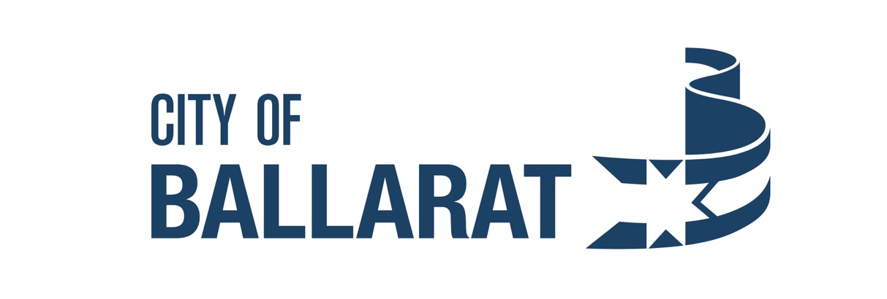

Template
Sponsor Survey
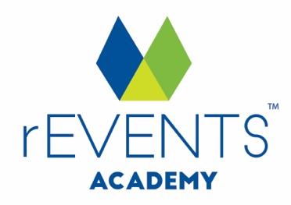
IMPORTANT: Copyright Notice
Except as permitted under the Copyright Act 1968 (Cth), you are not permitted to copy, reproduce, republish, distribute or display any of the information on our website or in our toolkits and resources without our prior written permission.
rEVENTS Academy maintains the copyright on all graphics, images, layouts, text, logos and trademarks contained within our website and toolkits. This includes following any removal of rEVENTS Academy branding and copyright notices for customisation of this document.
For our full terms and conditions go to www.reventsacademy.com

DISCLAIMER
While all care has been taken in the preparation of this material, no responsibility is accepted by the author for any errors, omissions or inaccuracies. The material provided in this checklist has been prepared to provide general information only. It is not intended to be relied upon or be a substitute for legal or other professional advice. No responsibility can be accepted by the author for any known or unknown consequences that may result from reliance on any information provided in this publication.

[Your Event] Sponsor Survey

The committee would like to thank you for supporting this year's [Your Event].
To ensure the community and committee can continually improve and grow the event, we invite you to provide feedback on your experience via our quick survey.

1. What is your company's name and where are you based?

2. How long have you been a partner of [Your Event]?
This was our first year
2 years
3+ years

3. What are your desired outcomes from a partnership with [Your Event]?
Brand awareness
Community engagement
Opportunity to sell at the event
Launch a product/service
Other (please specify)

4. How do you rate your outcomes from the partnership?
Excellent
Good
Satisfactory
Poor

5. How can we enhance the partnership arrangement to assist you with your objectives?

6. At this stage, are you considering a partnership with the event in [insert the year of the next event]?
Yes
No

7. Do you have any recommendations on how organisers can enhance the event?

Tip [delete from this survey before using]:
Sponsors are worth too much to only do a written/informal survey. It is recommended that every event sponsor is also contact personally for feedback. It’s much easier to retain an existing sponsor than it is to attract a new sponsor!

